Login to PLYSSQL146D.

Open SQL Server Management Studio.

Select the database **Allergan.**

**Generating History Data:**

1. Run the below query.

This will display the latest Data Month name for Norway. Here, latest month is M112012.

select * from Allergan_Load_Details where country = 'FR'.

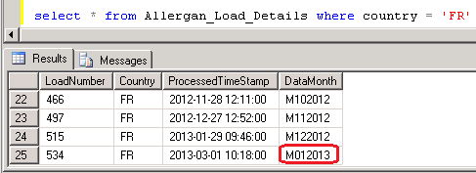

2. Run the Below query with the Latest Data Month Load Number.

This will display the backup data of M012013 Which was loaded in last production run.

select * from Allergan_Output_History where loadNumber = 534

3. Run the below query to check whether the latest production period data loaded or not

select * from Allergan_Load_Details where country = 'FR'.



5. Run the **MergePacks.exe** from D:\FTP\MergePacks tool\

6. Click on Build Report

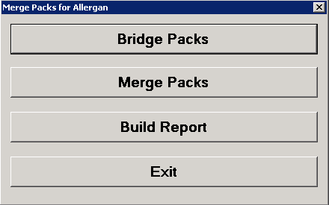

7. Select Country = FR and Previous Build = Previous Month. Click OK

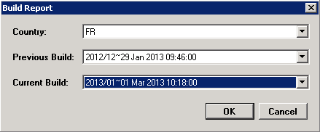

8. After successful run Below window will appear and the History Correction Report will generate at D:\FTP\MergePacks tool\Reports

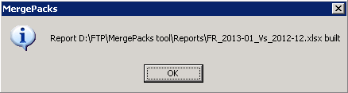

9. Copy the report file and backup at D:\FTP\MergePacks tool\Reports\YYYY\YYYYMM

where MM = Current Production Month Number (01, 02, ... 11,12)

and YYYY = Current Production Year.

10. Download the history excel file into Local and rename

History_Corrections_France_monYYYY.xlsx

where mon = Current Production Month Name

and YYYY = Current Production Year.

This file should mail to Allergan with delivery mail.

**Input Flat File vs Output Data:**

1. IPH-Pharmatrend (Madrid) will mail the input SA Cube

ALLERGAN N NPI C20100_21529__YYYYMMDD.zip

2. Login to 162.44.12.72 server.

3. Copy the output file Input file **Allergan_YYYYMM.zip**

from production server (PLYSSQL147P) D:\FTP\Allergan_Production_Output\Renamed_Outputs and paste at the location \\162.44.12.72\d$\Allergen\France\YYYYMM

where MM = Current Production Month Number (01, 02, ... 11,12)

and YYYY = Current Production Year.

4. Unzip **Allergan_YYYYMM.zip** we get 5 files

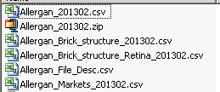

5. open input file **Allergan_201302.csv ,**output file **France_RSA.csv** and create **QC_France_YYYYMM.txt** with text pad.

6.press F5 in **Allergan_201302.csv**

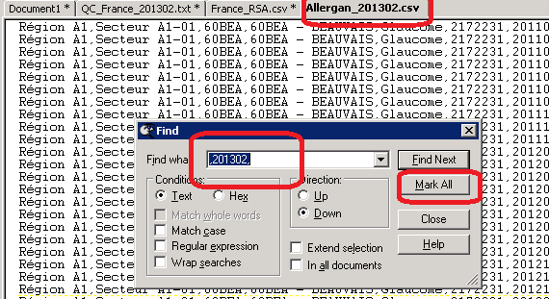

**7.**paste it on document 1

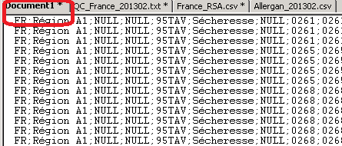

**8.** copy any record from document1 in **QC_France_YYYYMM.txt** then match the record with **France_RSA.csv** records….(after deleting all unusual record).

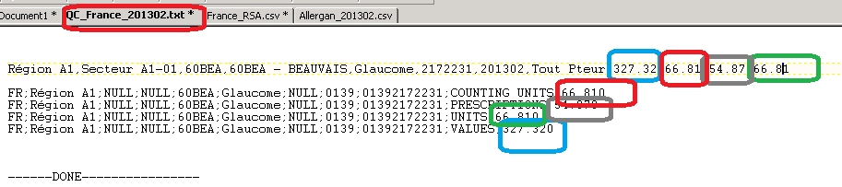

**Summary File Checking**

1. Open the Summary File **FranceSummary.txt** from Production Server (PLYSSQL147P) from the location D:\FTP\Allergan_Production_Output with TextPad

2. Check the ratio with the Previous month vs Current month.

3. Check if the ratio decrease of previous vs current for any measure, rest 2 will decrease also

NO;BTX FLAT;NULL;P0130701A;COUNTING UNITS;**1150.000;1116.000**

NO;BTX FLAT;NULL;P0130701A;UNITS;**1150.000;1116.000**

NO;BTX FLAT;NULL;P0130701A;VALUES;**1512671.000;1467945.000**

4. Check if the ratio increase of previous vs current for any measure, rest 2 will increase also

NO;S1E;NULL;P0103701;COUNTING UNITS;**7558.000;8540.000**

NO;S1E;NULL;P0103701;UNITS;**2870.000;3158.000**

NO;S1E;NULL;P0103701;VALUES;**578642.000;653843.000**